**Design Justification Donja Wolschrijn & Jonathan Willemsen**

The design elements we focussed on where the lines, we created a strong outlook with the banner lines. We focussed on good proportion of the content on the site and we made some paragraphs wider than others.

The shape space and high contrast in photos is used because it is attention grabbing. We create harmony by keeping it simple and clean. We are of the opinion that less is more and it is important to stick within our colour scheme to make it one certain style. We have made a favicon for brand recognition and it gives more detail to the pages We made also made a colour palate and we focussed on these colours that fit nicely together.

We added different fonts make the design clearer. Some Fonts

**Colour codes**

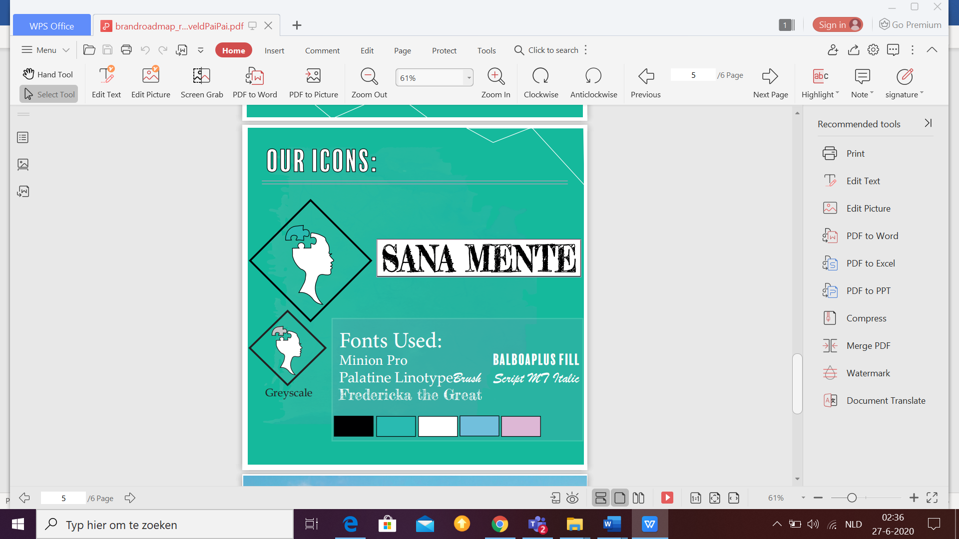

*#5dbcd2 (green)*

*#29bab1 (blue)*

*#ffffff (white)*

*#ddb7d5 (pink)*

**Fonts Used:**

FjallaOne Regular – Google Font

Bebas Nue

Avenir Next Condensed (Regular)

“Oswald” Sans-serif

Fredricka the Great – Google Font

**Wireframes**

**Workflow**

In our workflow we illustrated as a series of steps that shows the wat our people get our work done.

Step 1.

Idea websites are being talked about and brand is being developed.

Step 2.

One idea is chosen and way we decided on a one of the draft versions and the colour style is begin decided.

Step 3.

We made sure our bootstrap was correctly installed and we made sure the codes where correct. We used inspiration from other sites and we made the base of the website.

We made changes where needed and showed the understanding of html by applying the information we have learned. Besides the information and the styles of the website we added an favicon, an icon that was linked and google fonts. We made sure the website had a certain style focussed on the colours of the colour palette we put together. We also added the advertisement and pictures to make the website more appealing and noticeable for the customer

Step 4.

We developed our website tot all the requirements. Donja Wolschrijn wrote all the content and typed this already in code. Jonathan linked everything right and fixed problems on a technical aspect.

After the tester report and responses we improved the website to their preference so it would be more user friendly. For costumers who have ADHD or Dyslexia we made sure we used enough spacing between the paragraphs. We have also put more emphasises on certain sentence, the reason for this being that it will stand out more.

Step 5.

We handed it in after we both approved on it.

User tester methods

We collected information on the users in our target group which is from 20 to 30 years old. Their overall user experience was overall good but they missed a few designs the website lacked. To collect this feedback and their user experience we video called 4 users who gave their experience in an interview. The users have GitHub themselves so they downloaded the website we made and gave their opinion. We had the interview in-person with the user Edd Stanton. The other interviews where a remote usability test because it was over the internet.

**The number of test users:**

Have 4 Test users all in the age range of 20 to 30. We asked both men and women in the early twenties and who was almost 30 years old. We interviewed 1 girl with dyslexia and one young man with mild HDHD. They stated that the content would be more clear is the font was different and not all in capital letters with more spacing between them, so we improved on those points

**Conditions of tests:**

We try to have a bug free system for our test users The function was very good but it could have been more user friendly so we improved that after the feedback we received. We wanted to test our website and so far the design is improved a lot for clarity, and a good theme to go with.

Our tests were very effective because we held interviews so they could be very specific. We walked past everything they noticed and we wrote their opinions down to make a good and clear website.

**Xara Roelofs support used: actual website**

I would suggest using a white background instead of a grey one. I think that will give more of a fresh look to the website.

Blue won't clash with the grey background then anymore.

Lay-out is not very natural and it could possibly be changed so that everything looks really proportioned. It looks a bit weird that the text is on the same height as the logo. It would be better if it's underneath each other but not in a standard way but in a cascading way. That makes it more of a whole and it will make the flow more natural and fun.

You have the main header logo on the top right but it should be better if it is the central top.

**Yanni van Zijderveld PaiPai: prototype**

I like the site but I do not like the color at all. I would also make use of an icon or something because it now has not got one.

The logo is centered which is good because it is the about us page. The banners where very wide so they are dominating the page. I liked the brand itself and the information. If this was a real brand I would have checked it out for sure!

**Casper Hogeweg: actual website**

I liked the website, it had all the information it needed but it just needed something extra. The

Introduction to the design justifications because it is now very mystical where the link leads to. I think it could be more clear.

The “click here” Hyperlink would look better if you gave it an introduction.

You need to improve the services by making a few sentences more clear and highlighted. The header is needed for the services. The black bars need to be hanged to a light blue and they need spacing. I have dyslexia so it is easier for me if the spacing is better.

The current placement is sometimes very random of the content because on the right there is still a big space left. It might help if they are centralized. It is not symmetrical.

**Edd Stanton: actual website**

Make sure you use images with high contrast. It will make other uses more interested and you will grab their attention. I liked that there were so many pictures.

The border is also a way to massive and not proportional to the other header. The “feel free to contact us” text should not be in the same banner as the “contact us” because it is unnecessary and it has quite double. The contact box does not fit well at all with the grey background.

List of the things we improved due to the recommendations

User testing and usability issues Found recommendations for improvements based on user testing are a few items. The user testers have found that most of them did not like the grey/ brown background and it would look better in white. The spacing between the content was off but w managed to improve this. The user testing was good but we also changed the header and created outlines for more contrast. We also improved the size of the banners. Contact Us” was no longer more double written in also” send us a mail to “Contact Us” in a smaller font in the same banner.

We improved the “services” and we made sentences more highlighted and this makes it easier for people with dyslexia to read. We aligned everything and made the logos better. Besides the information and the styles of the website we added a favicon, and another icon that was linked and google fonts(page: contact us). We made sure the website had a certain style focussed on the colors of the color palette we put together. We also added the advertisement and pictures to make the website more appealing and noticeable for the customer.

[LINK TO WEBSITE](https://drive.google.com/file/d/1DlNH08yUJ3RRvojtyphLLua7qakt_Y14/view?usp=sharing)